Lab Assignment

T1

<!DOCTYPE html>

<html lang="en">

<head>

<meta charset="UTF-8">

<meta name="viewport" content="width=device-width, initial-scale=1.0">

<title>Alternating Background Colors</title>

<style>

ul li:nth-child(even) {

background-color: rgb(173, 216, 230);

}

</style>

</head>

<body>

<ul>

<li>Eswatini</li>

<li>Ecuador</li>

<li>Tanzania</li>

<li>Spain</li>

<li>Slovakia</li>

<li>Iraq</li>

</ul>

</body>

</html>

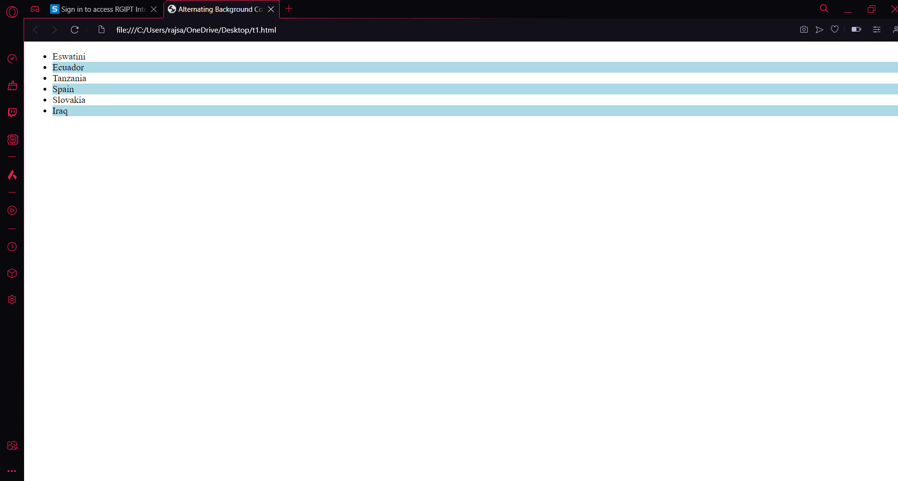

T2

<!DOCTYPE html>

<html lang="en">

<head>

<meta charset="UTF-8">

<meta name="viewport" content="width=device-width, initial-scale=1.0">

<title>Styled Table</title>

<style>

/\* CSS for table \*/

table {

font-family: Arial, sans-serif;

border-collapse: collapse;

width: 100%;

}

th {

background-color: black;

color: white;

font-size: 14px;

}

tr:nth-child(odd) {

background-color: lightgray;

}

td {

border: 1px solid #dddddd;

text-align: left;

padding: 8px;

font-size: 14px;

}

</style>

</head>

<body>

<table>

<thead>

<tr>

<th>Country</th>

<th>Capital</th>

<th>Language</th>

</tr>

</thead>

<tbody>

<tr>

<td>Albania</td>

<td>Tirana</td>

<td>Albanian</td>

</tr>

<tr>

<td>Papua New Guinea</td>

<td>Port Moresby</td>

<td>English</td>

</tr>

<tr>

<td>Latvia</td>

<td>Riga</td>

<td>Latvian</td>

</tr>

<tr>

<td>France</td>

<td>Paris</td>

<td>French</td>

</tr>

</tbody>

</table>

</body>

</html>

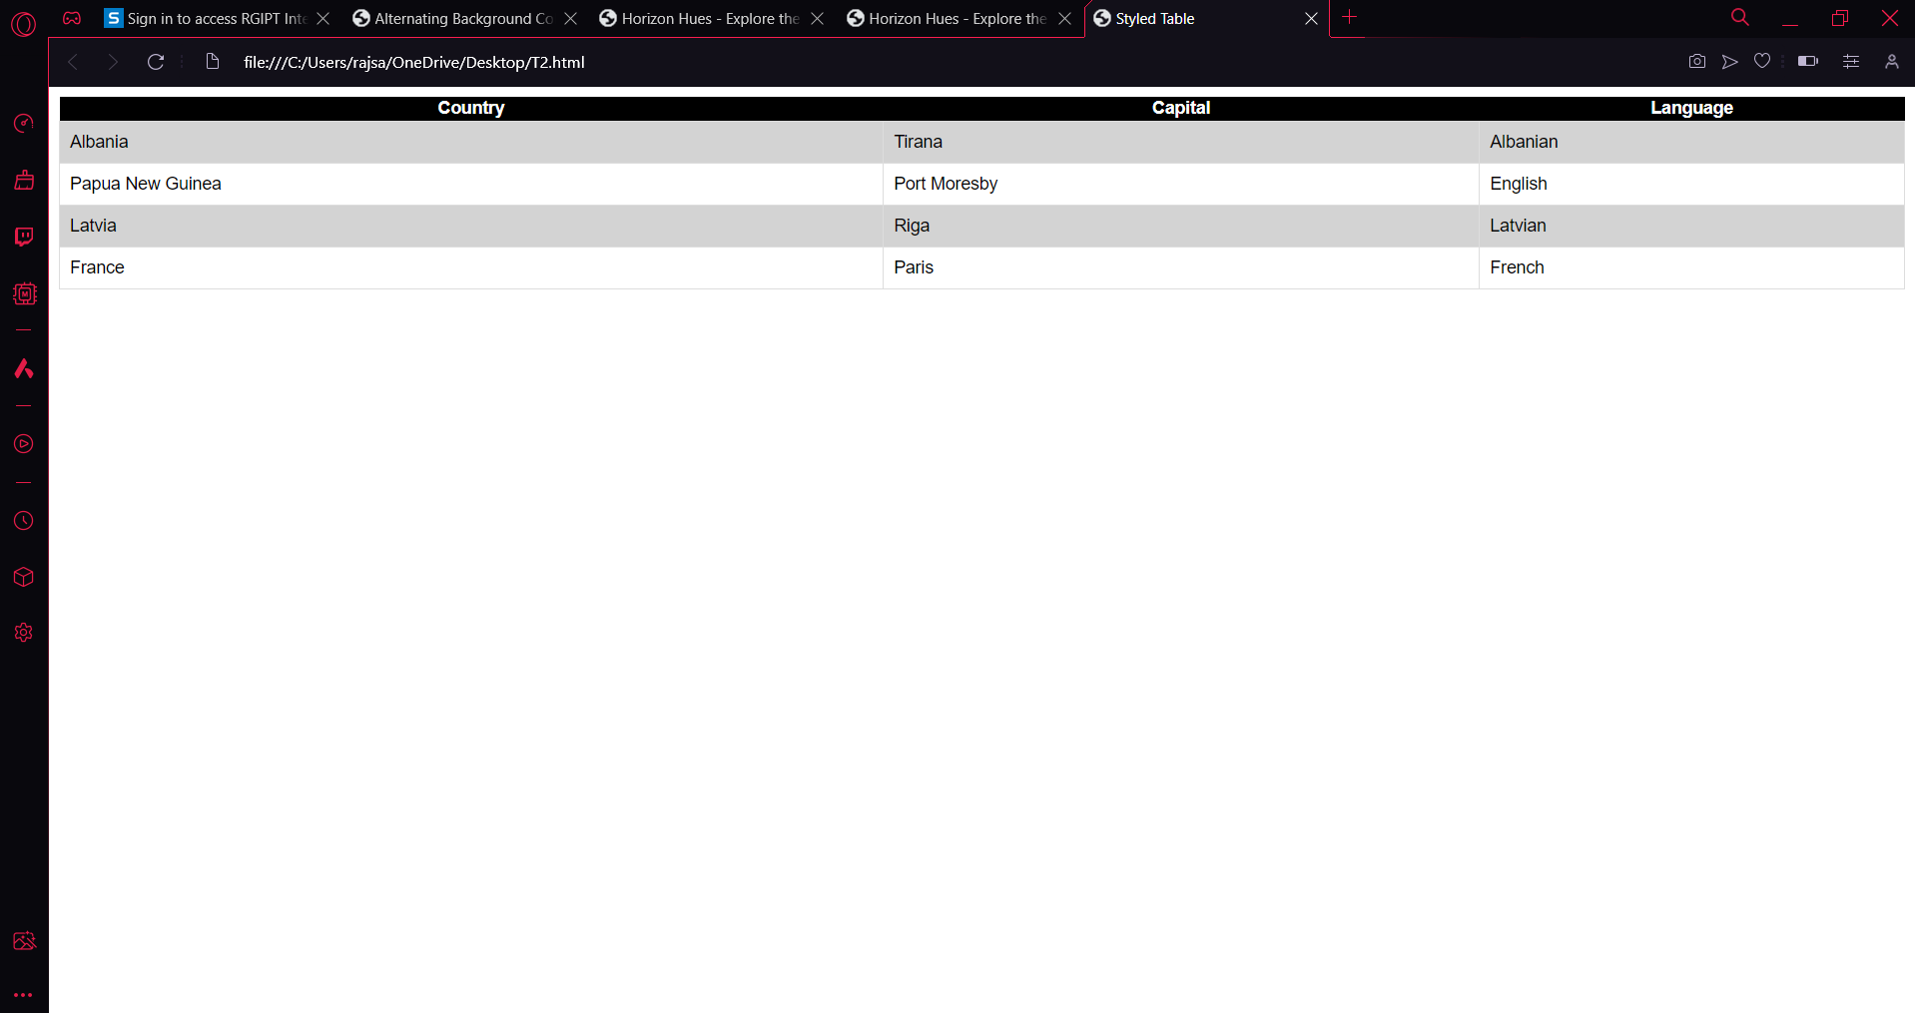

T3

<!DOCTYPE html>

<html lang="en">

<head>

<meta charset="UTF-8">

<meta name="viewport" content="width=device-width, initial-scale=1.0">

<title>Grilled Cheese Sandwich with Bacon and Tomato Recipe</title>

<style>

.meat {

background-color: lightcoral;

}

.vegetable {

background-color: lightgreen;

}

.dairy {

background-color: lightyellow;

}

h2 {

font-family: Arial, sans-serif;

}

.instructions {

font-style: italic;

}

</style>

</head>

<body>

<h1>Grilled Cheese Sandwich with Bacon and Tomato</h1>

<h2>Ingredients</h2>

<ul>

<li class="meat">Bacon</li>

<li class="dairy">Cheddar cheese</li>

<li class="vegetable">Tomato slices</li>

<li class="dairy">Butter</li>

<li class="dairy">Mayonnaise</li>

<li class="dairy">Bread slices</li>

</ul>

<h2>Instructions</h2>

<p class="instructions">1. Cook the bacon until crispy.</p>

<p class="instructions">2. Butter one side of each bread slice.</p>

<p class="instructions">3. Place a slice of cheese on the unbuttered side of a bread slice.</p>

<p class="instructions">4. Add tomato slices and cooked bacon on top of the cheese.</p>

<p class="instructions">5. Top with another bread slice, buttered side facing out.</p>

<p class="instructions">6. Heat a skillet over medium heat and place the sandwich in the skillet.</p>

<p class="instructions">7. Cook until the bread is golden brown and the cheese is melted, flipping halfway through.</p>

<p class="instructions">8. Serve hot and enjoy!</p>

</body>

</html>

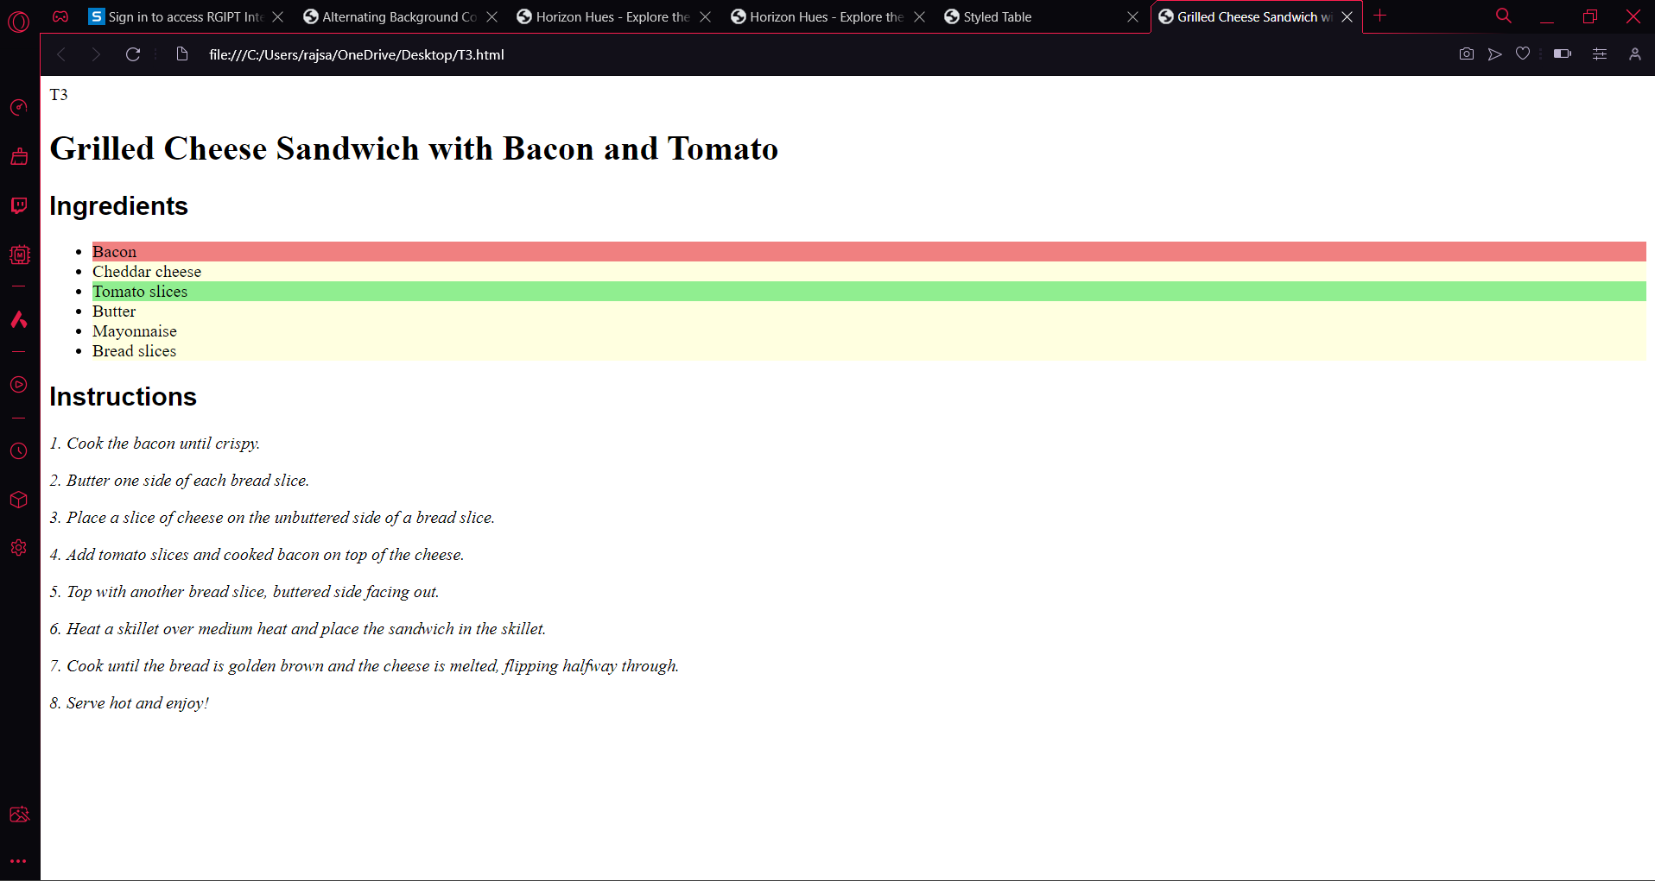

T4

<!DOCTYPE html>

<html lang="en">

<head>

<meta charset="UTF-8">

<meta name="viewport" content="width=device-width, initial-scale=1.0">

<title>Two-Column Webpage</title>

<style>

.container {

display: flex;

width: 100%;

}

.left-column, .right-column {

width: 50%;

padding: 20px;

}

.left-column {

background-color: lightyellow;

}

.right-column {

background-color: lightblue;

}

ul {

list-style-type: none;

padding: 0;

}

li {

margin-bottom: 10px;

}

</style>

</head>

<body>

<div class="container">

<div class="left-column">

<h2>Best Selling Books in Amazon Kindle Store</h2>

<ul>

<li>The Fault in our Stars</li>

<li>The Treasure Island </li>

<li>The Canterville Ghost</li>

<li>Invisible Man</li>

<li>Flames of Fire</li>

</ul>

</div>

<div class="right-column">

<h2>My Favorite Celebrities/Athletes</h2>

<ul>

<li>Rohit Sharma</li>

<li>Emma Watson</li>

<li>Selena Gomez</li>

<li>Christiano Ronaldo</li>

<li>ED Sheeran</li>

</ul>

</div>

</div>

</body>

</html>

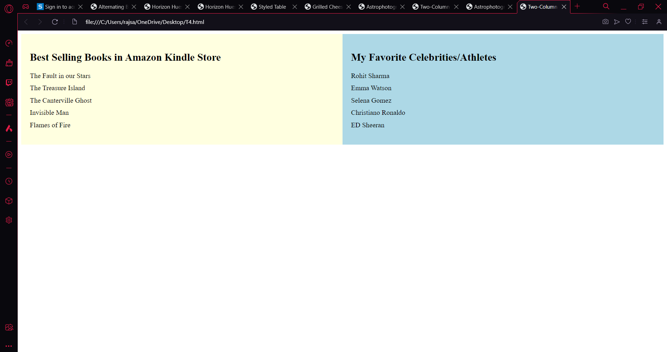

T5

<!DOCTYPE html>

<html lang="en">

<head>

<meta charset="UTF-8">

<meta name="viewport" content="width=device-width, initial-scale=1.0">

<title>Sample Webpage with Navbar</title>

<style>

nav {

background-color: lightblue;

padding: 10px;

}

ul {

list-style-type: none;

margin: 0;

padding: 0;

}

li {

display: inline;

margin-right: 20px;

}

a {

text-decoration: none;

color: black;

}

#navbar-title:hover {

background-color: navy;

color: white;

}

</style>

</head>

<body>

<nav>

<ul>

<li><a id="navbar-title" href="#">Sample Website</a></li>

<li><a href="#">Home</a></li>

<li><a href="#">About</a></li>

<li><a href="#">Contact</a></li>

</ul>

</nav>

Stargazing

STARGAZING BASICS

Astronomy can be daunting for beginners — after all there’s a whole universe out there! But stargazing basics don’t have to be hard. Sky & Telescope editors (with more than 100 years of collective experience) are here to help you learn your way around the night sky. Whether you’re looking for your first telescope, trying to learn the constellations, or want to learn to use star charts, you’ve come to the right place. The best way to start exploring the night sky is with the unaided eye. Our star wheels are easy to use, and in no time you’ll learn the constellations and names of the stars. And that’s only the beginning!

</body>

</html>

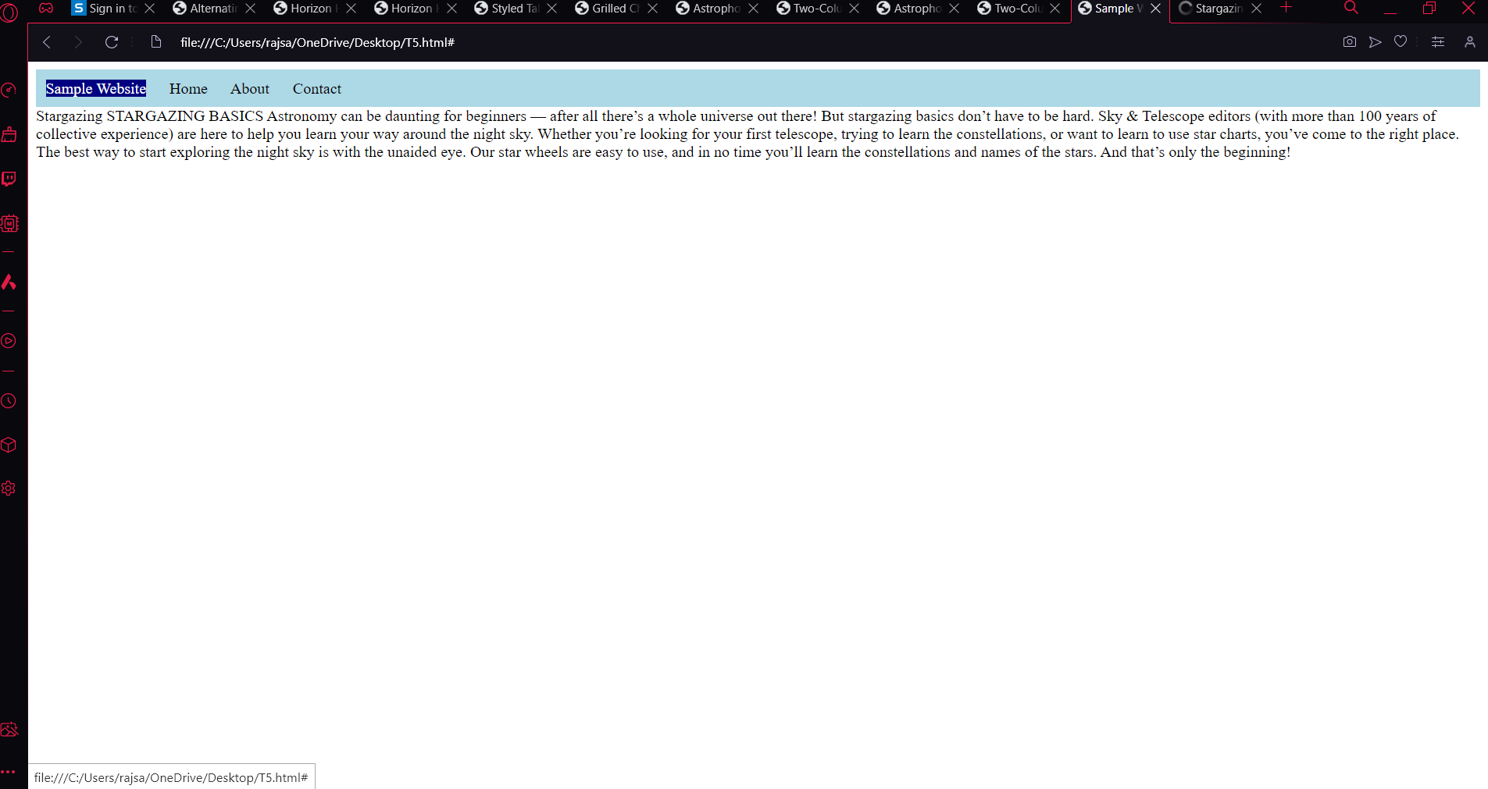

T7

<!DOCTYPE html>

<html lang="en">

<head>

<meta charset="UTF-8">

<meta name="viewport" content="width=device-width, initial-scale=1.0">

<title>My Homepage</title>

<link rel="stylesheet" href="styles.css">

</head>

<body>

<div class="navbar">

<ul>

<li><a href="homepage.html">Home</a></li>

<li><a href="hobbies.html">Hobbies</a></li>

<li><a href="favorite-teams.html">Favorite Teams</a></li>

</ul>

</div>

<div class="container">

<div class="column">

<h2>About Me</h2>

<p>Hello My name is Sarthak Raj</p>

</div>

<div class="column">

<h2>Latest Updates</h2>

<p>I am in RGIPT</p>

</div>

</div>

<footer>

<p>&copy; 2024 Your Name</p>

</footer>

</body>

</html>

<!DOCTYPE html>

<html lang="en">

<head>

<meta charset="UTF-8">

<meta name="viewport" content="width=device-width, initial-scale=1.0">

<title>My Hobbies</title>

<link rel="stylesheet" href="styles.css">

</head>

<body>

<div class="navbar">

<ul>

<li><a href="homepage.html">Home</a></li>

<li><a href="hobbies.html">Hobbies</a></li>

<li><a href="favorite-teams.html">Favorite Teams</a></li>

</ul>

</div>

<div class="container">

<h2>Hobbies</h2>

<p>My Hobbies are <br>

<ul>

<li> Travelling</li>

<li> Reading</li>

<li> Stargazing</li>

</ul></p>

</div>

<footer>

<p>&copy; 2024 Your Name</p>

</footer>

</body>

</html>

<!DOCTYPE html>

<html lang="en">

<head>

<meta charset="UTF-8">

<meta name="viewport" content="width=device-width, initial-scale=1.0">

<title>Favorite Teams</title>

<link rel="stylesheet" href="styles.css">

</head>

<body>

<div class="navbar">

<ul>

<li><a href="homepage.html">Home</a></li>

<li><a href="hobbies.html">Hobbies</a></li>

<li><a href="favorite-teams.html">Favorite Teams</a></li>

</ul>

</div>

<div class="container">

<h2>Favorite Teams</h2>

<p>Here you can list your favorite sports teams.

<ul>

<li> Real Madrid</li>

<li> Barcelona</li>

<li> Mumbai Indians</li>

</ul>

</p>

</div>

<footer>

<p>&copy; 2024 Your Name</p>

</footer>

</body>

</html>

.navbar {

position: fixed;

top: 0;

width: 100%;

background-color: #333;

}

.navbar ul {

list-style-type: none;

margin: 0;

padding: 0;

overflow: hidden;

}

.navbar li {

float: left;

}

.navbar li a {

display: block;

color: white;

text-align: center;

padding: 14px 20px;

text-decoration: none;

}

.navbar li a:hover {

background-color: #ddd;

color: black;

}

.container {

margin-top: 50px;

display: flex;

}

.column {

flex: 50%;

padding: 20px;

}

/\* Footer styles \*/

footer {

position: fixed;

bottom: 0;

width: 100%;

background-color: #333;

color: white;

text-align: center;

padding: 10px 0;

}

